## Front End Engineering-II /Artificial

## Intelligence and Machine Learning

Project Report

Semester-IV (Batch-2022)

Title of the Project

**Supervised By: Submitted By:**

Faculty Name Yash Kaushik

2210990974

**Department of Computer Science and Engineering**

**Title:** MoCart: Redefining Online Shopping through Personalization and Innovation

**Abstract:**

MoCart is a next-generation online shopping platform that aims to revolutionize the e-commerce landscape through its commitment to personalized experiences and technological innovation. In today's digital age, consumers demand more than just convenience; they seek tailored recommendations, social interaction, and seamless transactions. MoCart addresses these needs by leveraging advanced algorithms, intuitive design, and cutting-edge features to create a shopping environment that is intuitive, engaging, and secure.

At the heart of MoCart is its personalized recommendation engine, which analyzes user behavior, preferences, and past purchases to curate a bespoke shopping journey for each individual. By harnessing the power of data science and machine learning, MoCart ensures that users are presented with products that resonate with their tastes and preferences, thereby enhancing their overall shopping experience and increasing the likelihood of conversion.

Moreover, MoCart integrates social shopping elements to foster community engagement and peer-to-peer interaction. Users can share their favorite products, seek recommendations from friends and influencers, and participate in discussions about trending items and brands. This social validation not only adds a layer of trust to the shopping process but also enhances the sense of belonging and community among users.

In terms of user experience, MoCart prioritizes simplicity, speed, and accessibility. The platform boasts a sleek and intuitive interface, streamlined navigation, and robust search functionalities, ensuring that users can easily find what they're looking for and complete transactions with minimal friction. Additionally, MoCart employs state-of-the-art security measures to protect user data and transactions, giving users peace of mind knowing that their information is safe and secure.

Furthermore, MoCart is committed to sustainability and ethical sourcing. The platform partners with eco-friendly brands and provides transparent information about the environmental impact of products, empowering users to make informed and responsible purchasing decisions.

In summary, MoCart represents a paradigm shift in online shopping, combining the latest technology with a customer-centric approach to deliver personalized, engaging, and seamless experiences for users. Whether browsing for everyday essentials or seeking unique treasures, MoCart offers a tailored shopping journey that caters to the diverse needs and preferences of modern consumers.

**Introduction**

In today's digital age, online shopping has become an integral part of our lives, offering convenience, variety, and accessibility like never before. As consumers increasingly turn to e-commerce for their purchasing needs, the demand for platforms that prioritize personalized experiences, innovation, and security continues to rise. In response to these evolving needs, MoCart emerges as a pioneering online shopping destination, poised to redefine the way we shop and interact with brands in the digital realm.

**The Evolution of Online Shopping**

The journey of online shopping began decades ago, marked by the advent of e-commerce giants like Amazon and eBay, which paved the way for a new era of retail. Initially, online shopping was primarily driven by convenience, allowing consumers to browse and purchase products from the comfort of their homes. However, as the e-commerce landscape evolved, so too did consumer expectations.

**Changing Consumer Expectations**

Today's consumers are more discerning and demanding than ever before. They seek personalized recommendations, social validation, and seamless experiences across all touchpoints. Traditional e-commerce platforms, while successful in meeting basic needs, often fall short in delivering on these heightened expectations. Recognizing this gap, MoCart sets out to disrupt the status quo by offering a fresh approach to online shopping that prioritizes personalization, innovation, and community engagement.

**Introducing MoCart: A New Frontier in Online Shopping**

MoCart represents a convergence of technology, design, and user-centricity, aimed at creating a shopping experience that is intuitive, engaging, and secure. At its core, MoCart is driven by a commitment to understanding and catering to the unique needs and preferences of each individual user. Through the utilization of advanced algorithms and machine learning, MoCart analyzes user behavior, purchase history, and demographic data to deliver personalized product recommendations tailored to each user's tastes and preferences.

**Personalization: The Key to Enhanced Shopping Experiences**

Personalization lies at the heart of MoCart's value proposition. By harnessing the power of data science and artificial intelligence, MoCart not only anticipates user needs but also adapts and evolves with each interaction. Whether it's recommending relevant products, providing targeted promotions, or offering curated collections, MoCart ensures that every touchpoint is tailored to enhance the user experience and drive engagement.

**Social Shopping: Building Community and Trust**

In addition to personalized recommendations, MoCart integrates social shopping features to foster community engagement and peer-to-peer interaction. Users can share their favorite products, seek recommendations from friends and influencers, and participate in discussions about trending items and brands. This social validation not only adds a layer of trust to the shopping process but also enhances the sense of belonging and community among users.

**Security and Reliability: Ensuring Peace of Mind**

Furthermore, MoCart prioritizes security and reliability, implementing robust encryption protocols and secure payment gateways to safeguard user data and transactions. By adhering to the highest standards of security and compliance, MoCart instills confidence in users, assuring them that their information is protected every step of the way.

**Software Requirements for MoCart:**

1. Web Browser: MoCart is primarily accessed through web browsers. It is compatible with popular browsers such as Google Chrome, Mozilla Firefox, Safari, and Microsoft Edge.

2. Operating System Compatibility: MoCart supports multiple operating systems, including Windows, macOS, Linux, Android, and iOS, ensuring accessibility across a wide range of devices.

3. Database Management System: MoCart utilizes a robust database management system (DBMS) to store and manage user data, product information, and transaction records. Commonly used systems include MySQL, PostgreSQL, MongoDB, or similar relational or NoSQL databases.

4. Server Environment: MoCart requires a server environment to host its web application. This server environment typically includes a web server, such as Apache or Nginx, and a server-side scripting language, such as PHP, Python, Node.js, or Ruby on Rails.

5. Security Software: To ensure the security of user data and transactions, MoCart may integrate with security software solutions such as SSL certificates for encrypting data transmitted over the internet, firewalls, intrusion detection systems (IDS), and antivirus software.

6. Payment Gateway Integration: MoCart integrates with payment gateway providers to facilitate secure online transactions. Popular payment gateways include PayPal, Stripe, Square, and Authorize.Net. Integration with these providers may require specific software development kits (SDKs) or application programming interfaces (APIs).

7. Content Management System (CMS): MoCart may incorporate a CMS for managing website content, product listings, and promotional materials. Common CMS platforms include WordPress, Drupal, Joomla, or custom-built solutions tailored to MoCart's specific requirements.

**Hardware Requirements for MoCart:**

1. Web Server: MoCart's web application is hosted on a web server, which requires adequate processing power, memory, and storage capacity to handle incoming requests, execute code, and serve web pages efficiently. The specific hardware specifications depend on factors such as expected traffic volume, concurrent users, and the complexity of the application.

2. Database Server: The database server hosts the database management system used by MoCart to store and retrieve data. Similar to the web server, the hardware requirements for the database server depend on factors such as database size, transaction volume, and performance requirements.

3. Load Balancer (Optional): For high-traffic websites, MoCart may employ a load balancer to distribute incoming traffic across multiple web servers, improving scalability, reliability, and performance. The hardware specifications for the load balancer depend on factors such as anticipated traffic volume and the number of backend servers being load-balanced.

4. Network Infrastructure: MoCart requires a stable and high-speed network infrastructure to ensure seamless communication between clients, servers, and external services. This includes routers, switches, cables, and other networking equipment capable of supporting the required bandwidth and minimizing latency.

5. Client Devices: Users access MoCart from various client devices, including desktop computers, laptops, smartphones, and tablets. While MoCart does not impose specific hardware requirements on client devices, users should ensure they have compatible hardware and up-to-date web browsers to access the platform optimally.

6. Backup and Redundancy Infrastructure: To ensure data integrity and continuity of service, MoCart may implement backup and redundancy infrastructure, including redundant servers, storage arrays, and backup systems. The hardware specifications for these components depend on factors such as data volume, retention policies, and recovery time objectives (RTOs) and recovery point objectives (RPOs).

**Conclusion**

In conclusion, MoCart represents a paradigm shift in online shopping, offering a personalized, engaging, and secure shopping experience that is unparalleled in the e-commerce landscape. By combining advanced technology with a deep understanding of user needs, MoCart sets a new standard for online retail, empowering users to discover, connect, and shop with confidence. As we embark on this journey together, MoCart invites you to explore a world of possibilities and reimagine the way you shop online. Welcome to the future of e-commerce. Welcome to MoCart.

**HTML CODE SCREENSHOTS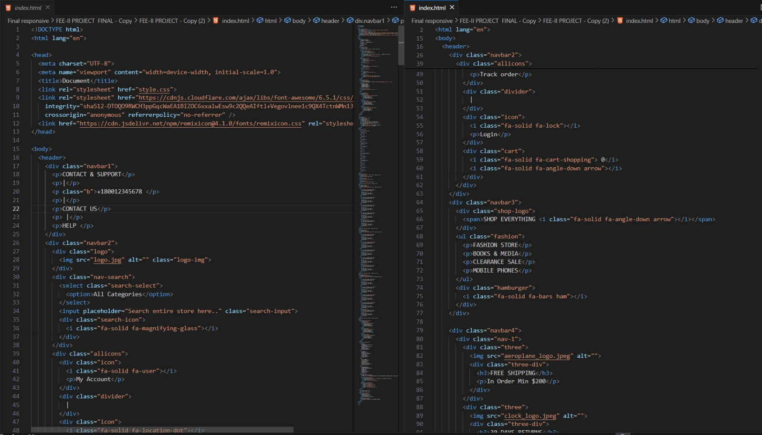:**

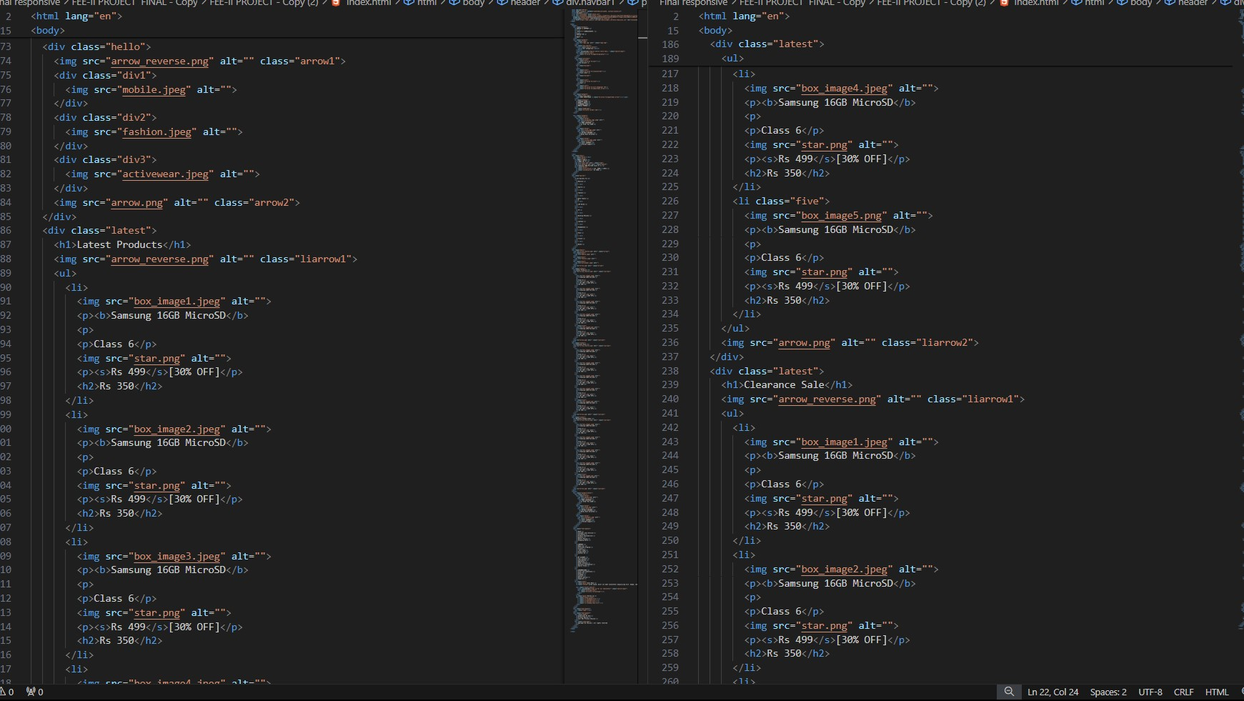

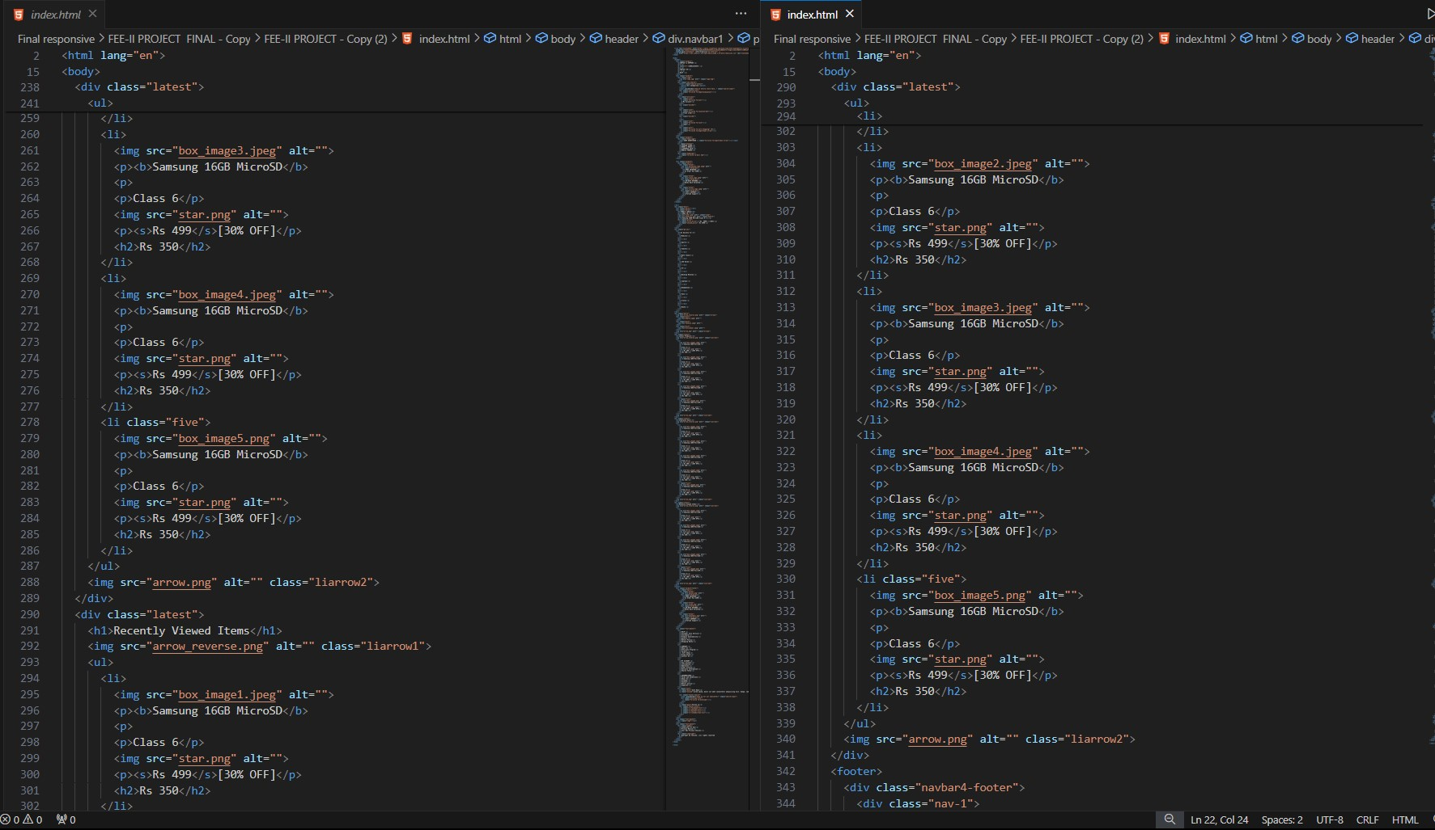

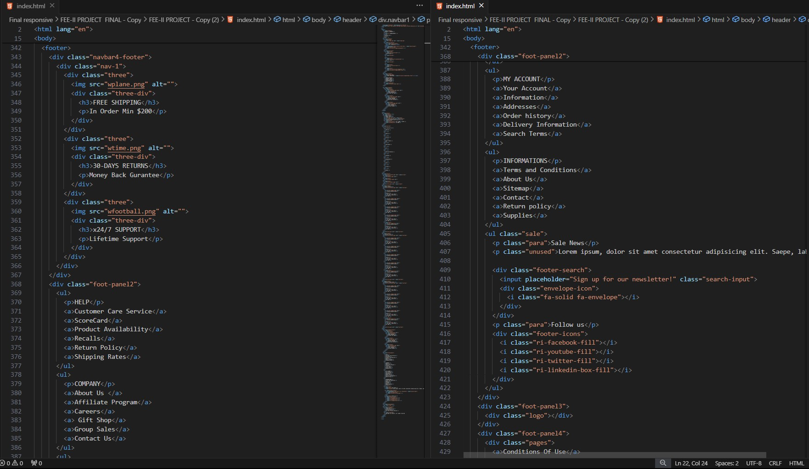



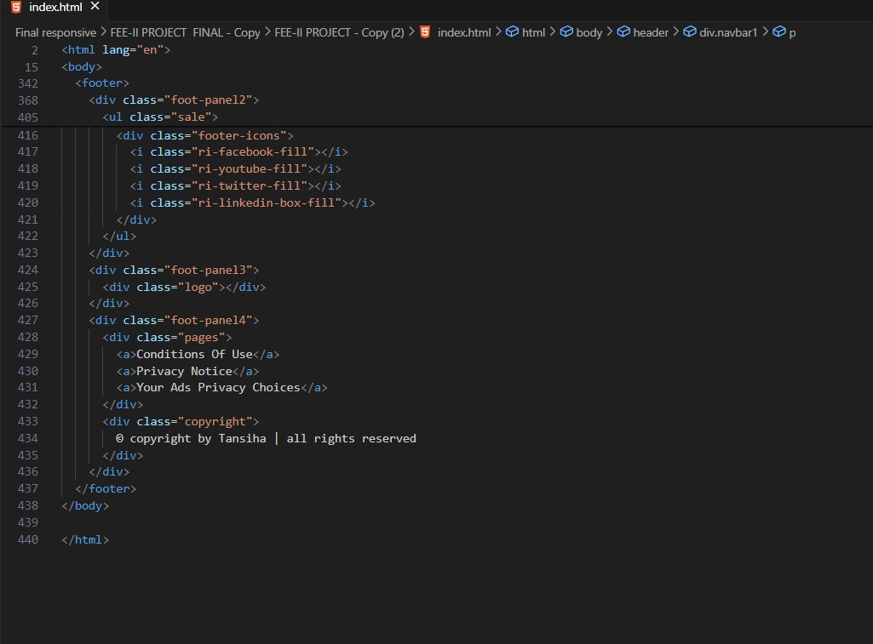

**CSS CODE SCREENSHOTS:**

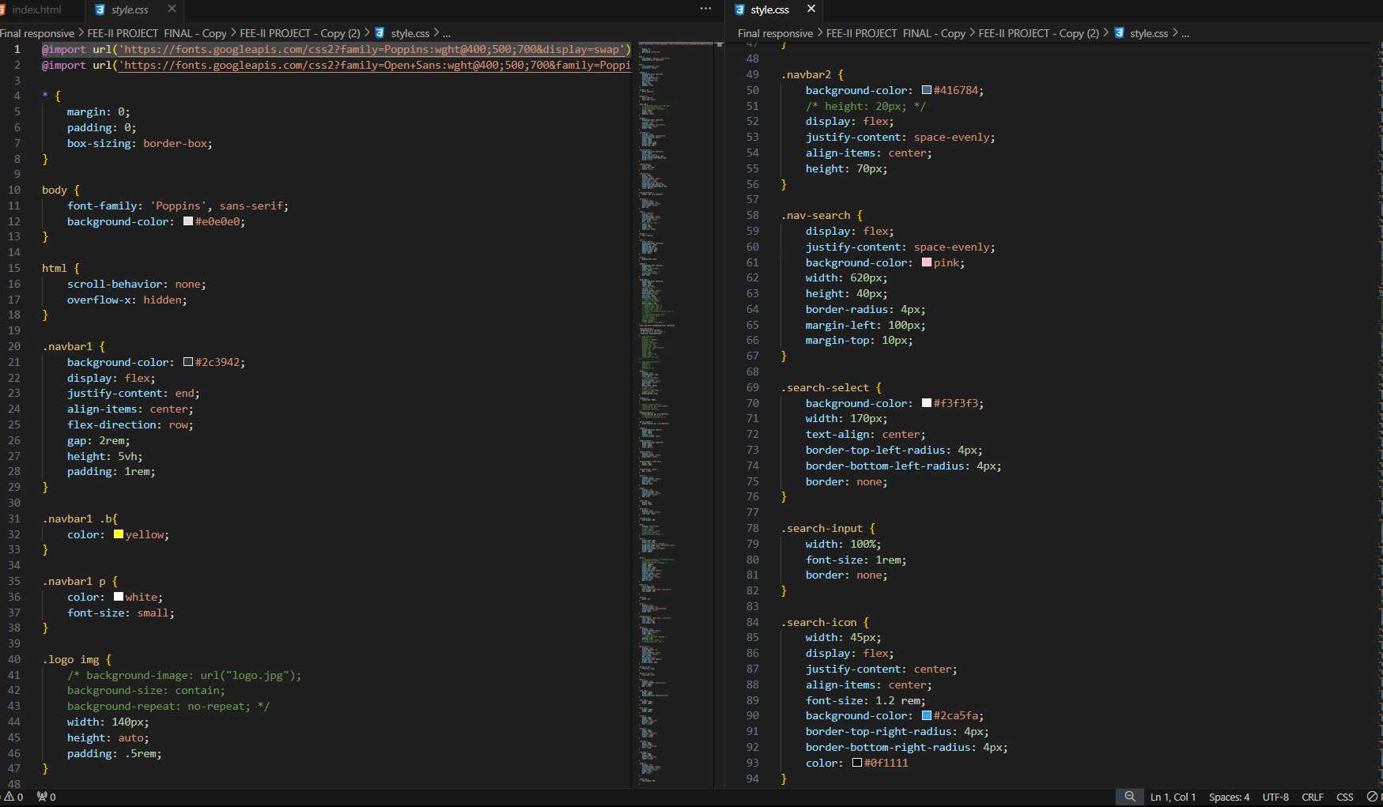

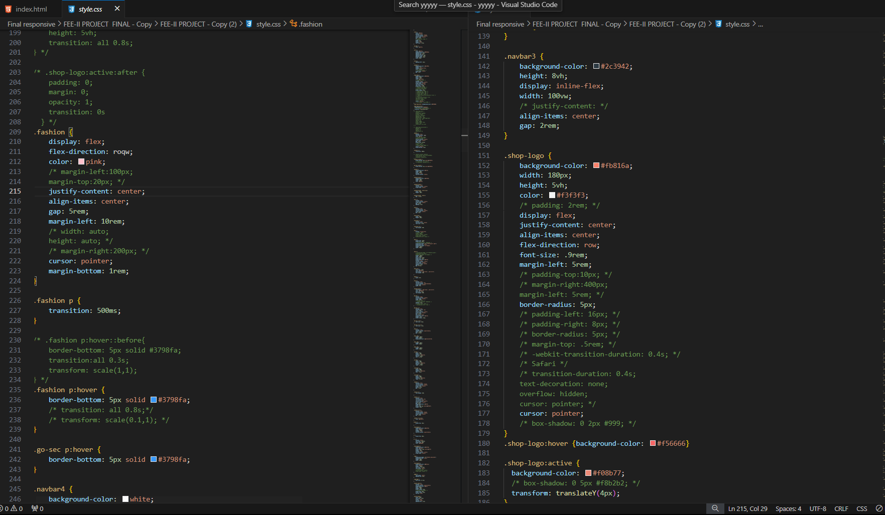

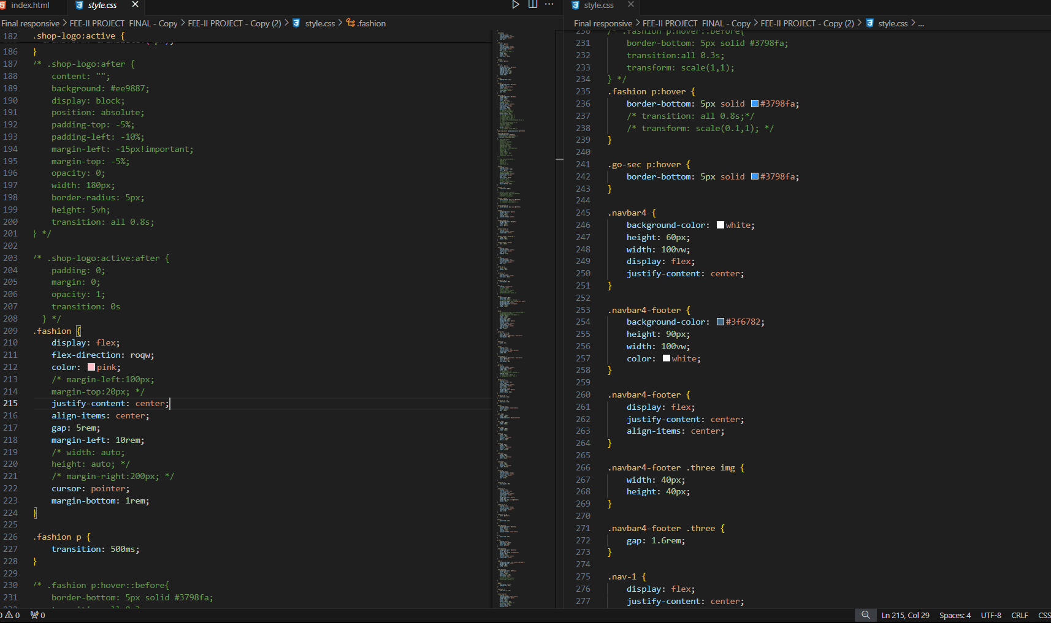

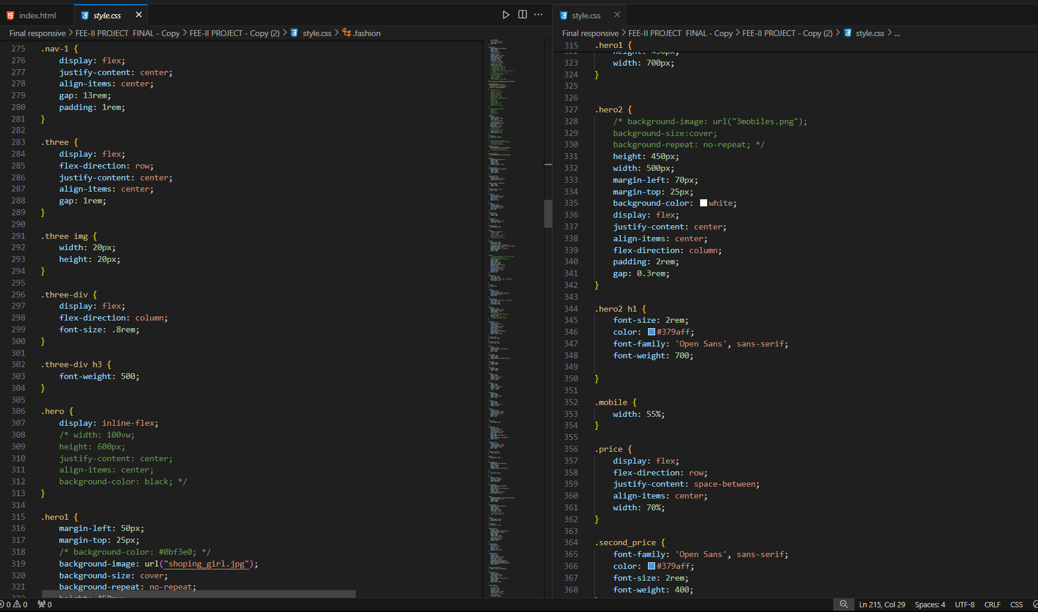

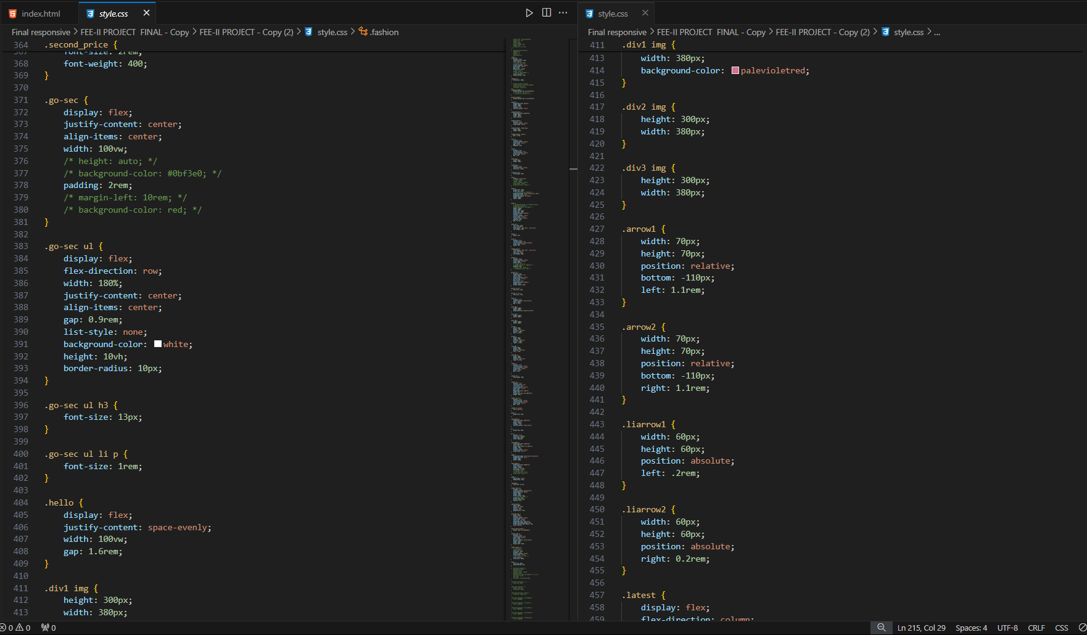

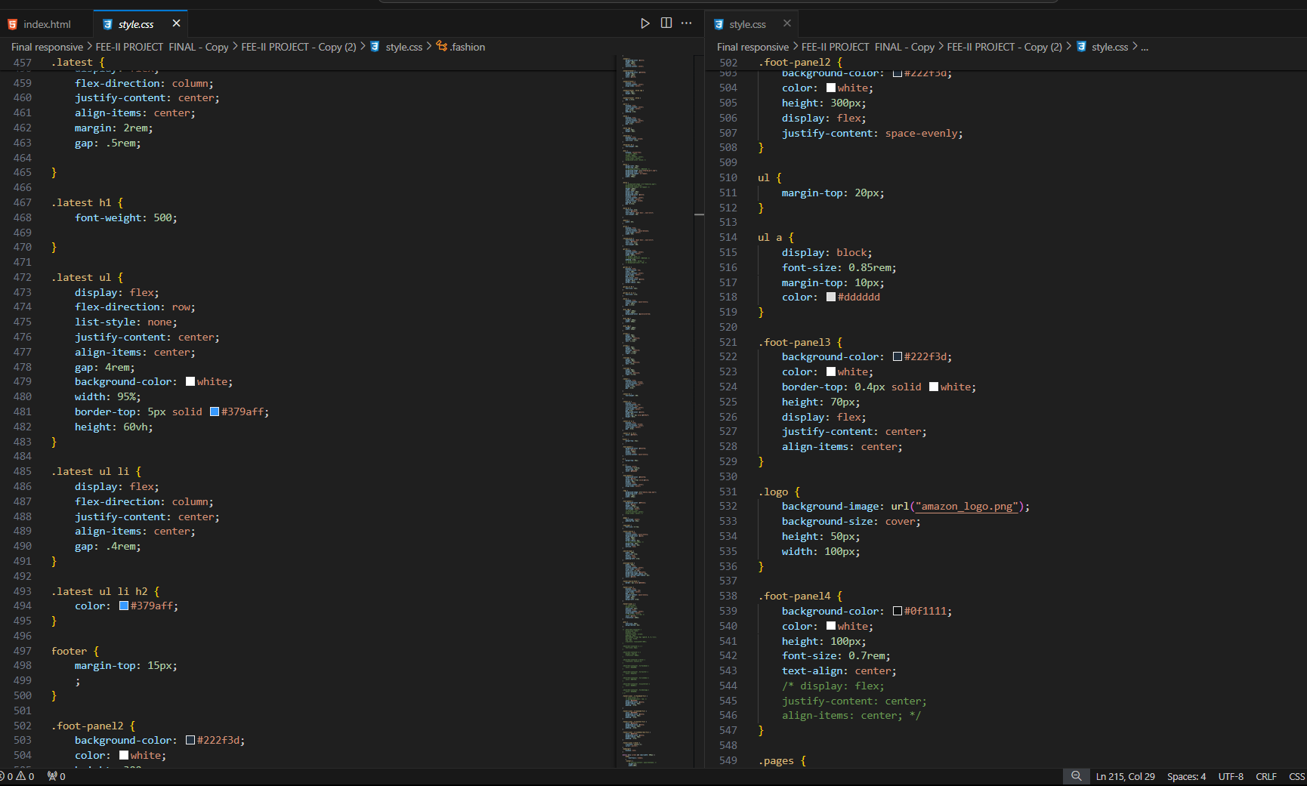

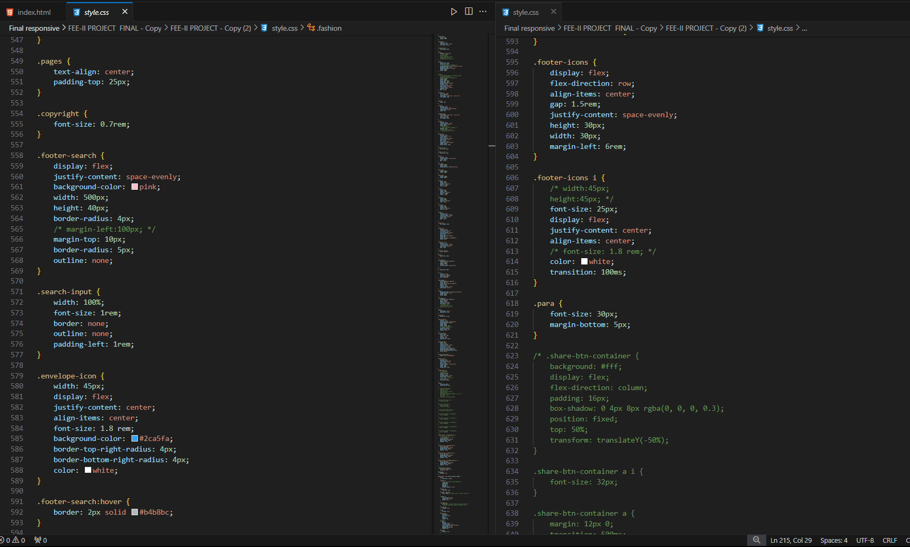

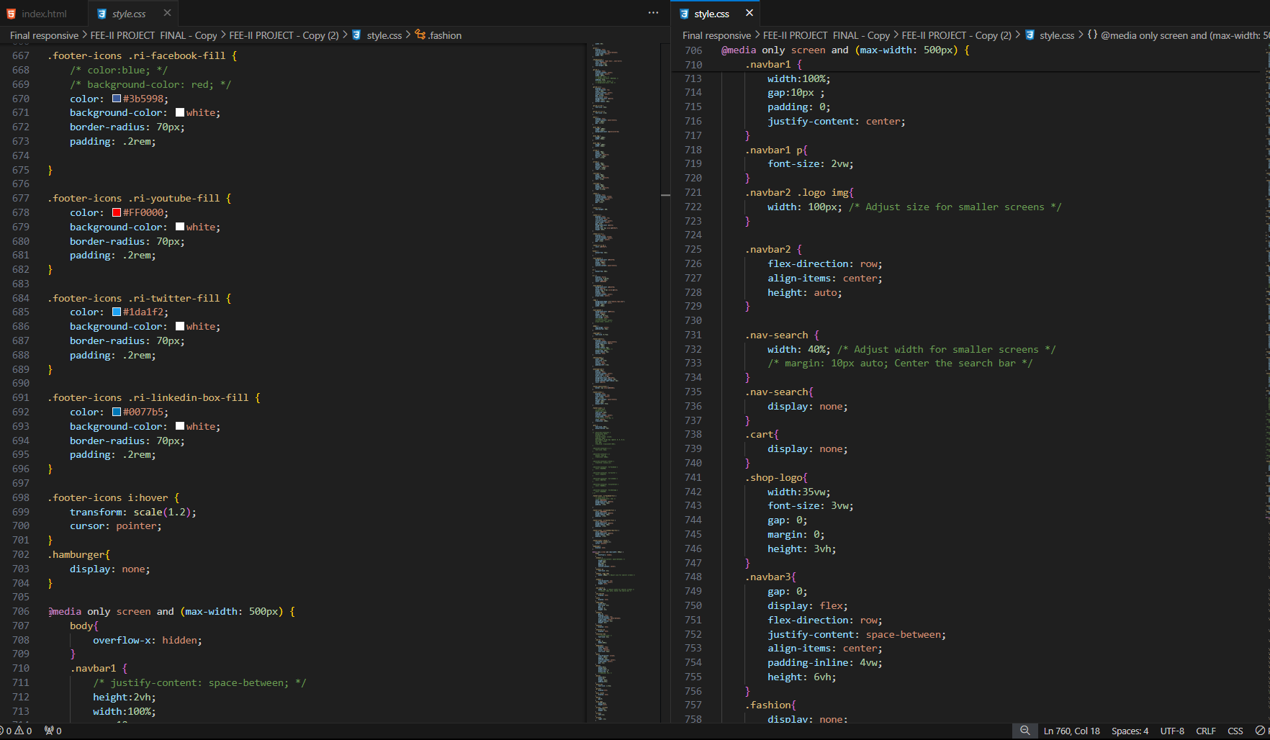

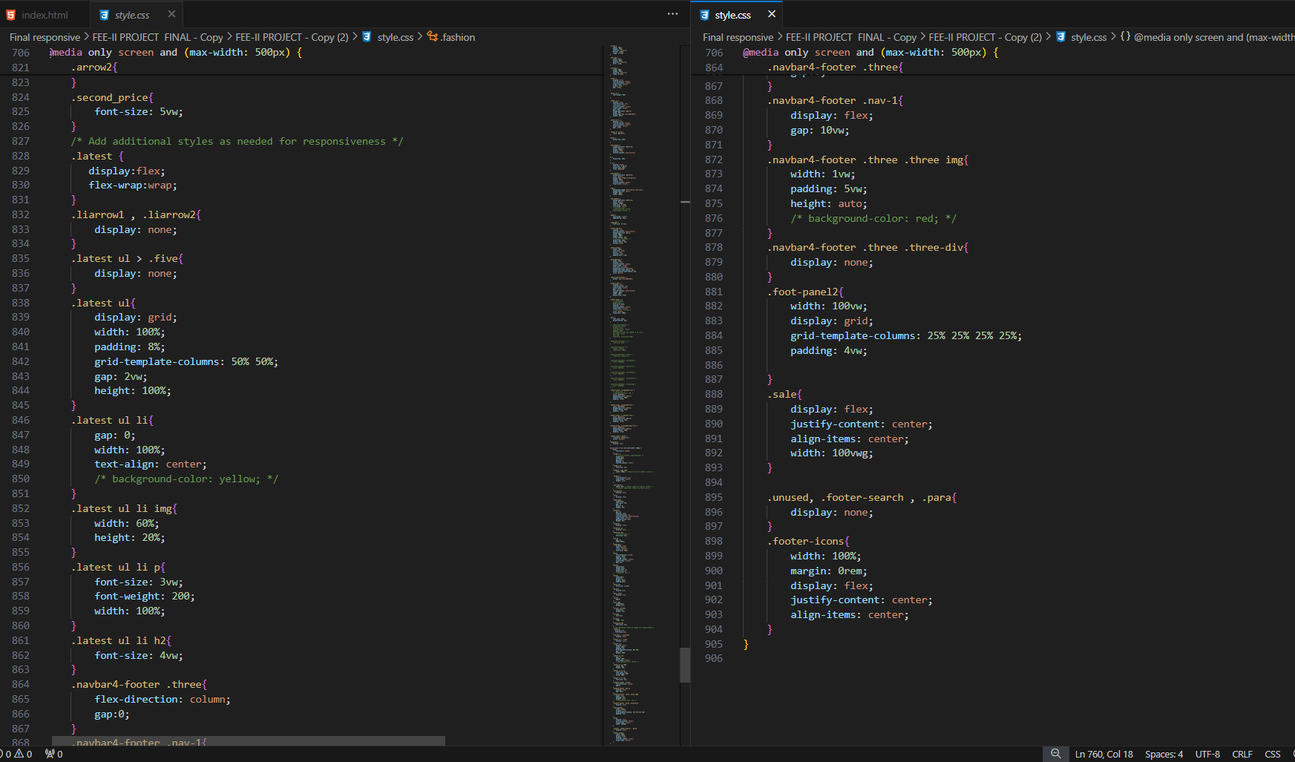

**THANK YOU**